**Experiment – 2.3**

**Student Name: Milan Sharma UID: 23MAI10003**

**Branch: ME – CSE - AIML Section/Group: MAI – 1 (A)**

**Semester: 1st Date of Performance: 11 Oct 2023**

**Subject Name: Python Programming Subject Code: 23 CSH 623**

1. **Aim of the Experiment :**

Write a python program to create a tuple and perform different operations on it using different inbuilt functions

1. **Objective of the Experiment :**

To create a tuple and perform different operations on it using different inbuilt functions

1. **Algorithm/ Steps for Experiment**

**Step 1:** Create a python file to perform the python programs.

**Step 2:** Create a tuple in python.

**Step 3:** Create an empty tuple then add elements in tuple.

**Step 4:** Access the elements of tuple.

**Step 5:** Traverse the tuple and print all elements.

**Step 6:** Delete the elements of the tuple.

**Creating a tuple:**

**Code for Experiment :**

Tuple1 = ()

print("Initial empty Tuple: ")

print(Tuple1)

Tuple1 = ('Time', 'For')

print("\nTuple with the use of String: ")

print(Tuple1)

list1 = [1, 2, 4, 5, 6]

print("\nTuple using List: ")

print(tuple(list1))

Tuple1 = tuple('Coding')

print("\nTuple with the use of function: ")

print(Tuple1)

**Result/Output :**

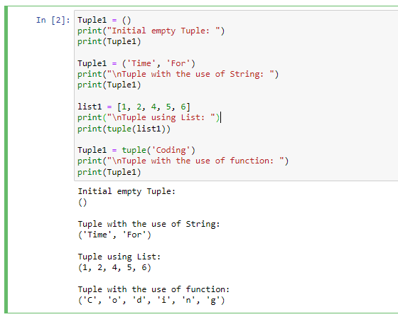

**Different inbuilt functions:**

**Code for Experiment :**

Tuple1 = (0, 1, 2, 3)

Tuple2 = ('Ready', 'For', 'Coding')

print("Tuple1 :",Tuple1)

print("Tuple2 :",Tuple2)

print ("length of tuple1 : ",len(Tuple1))

print ("Maximum Value in tuple1",max(Tuple1))

print ("Minimum Value in tuple1",min(Tuple1))

Tuple3 = Tuple1 + Tuple2

print("\nTuples after Concatenation: ")

print(Tuple3)

Tuple3=tuple('ABCDEFGHIJKLMNOP')

print("\nPrinting elements between Range 4-9:",Tuple3[4:9])

#Deleting the tuple

print("\nAfter deleting the tuple message recieved:")

del Tuple2

print(Tuple2)

**Result/Output :**

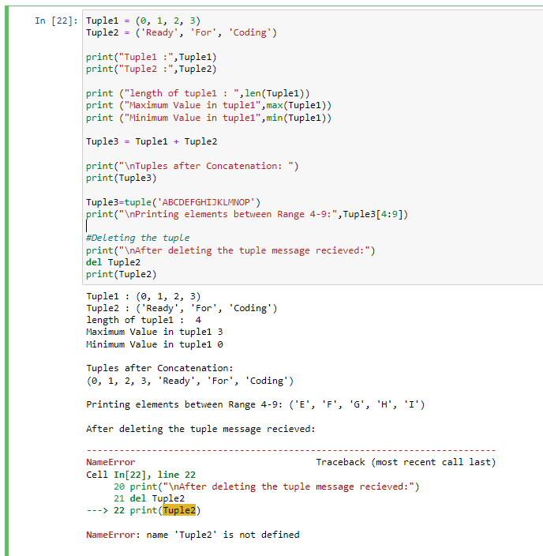

**Indexing and Slicing in tuple :**

**Code for Experiment :**

# tuple containing vowels

vowels = ('a', 'e', 'i', 'o', 'i', 'u')

# index of 'e' in vowels

index = vowels.index('e')

print('Index of e:', index)

# index of the first 'i' is returned

index = vowels.index('i')

print('Index of i:', index)

tuple= ('a','b','c','d','e','f','g','h','i','j')

print("\n")

print("After Slicing tuple[0:6]",tuple[0:6])

print("After slicing tuple[1:9:2]",tuple[1:9:2])

print("After Slicing tuple[-1:-5:-2]",tuple[-1:-5:-2])

**Result/Output :**

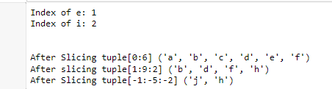

**Learning outcomes (What I have learnt):**

1. I learnt about the python language and its basic syntax.
2. I learnt about how create a tuple in python.
3. I learnt about how to traverse and add items in tuple.
4. I learnt about how to slice the data in the tuple.
5. I learnt about different inbuilt functions for tuple.\.

**Evaluation Grid (To be created as per the SOP and Assessment guidelines by the faculty):**

|  |  |  |  |
| --- | --- | --- | --- |
| **Sr. No.** | **Parameters** | **Maximum Marks** | **Marks Obtained** |
| **1.** | **Student Performance**  **(Conduct of experiment)**  **Objectives/Outcomes.** | 12 |  |
| **2.** | **Viva Voce** | 10 |  |
| **3.** | **Submission of Work Sheet**  **(Record)** | 8 |  |